**FACULTY OF COMPUTER AND INFORMATION TECHNOLOGY**

**SEPTEMBER 2022**

**Project Object Oriented Programming**

**Financial Budgeting Application**

**Prepare for: Sir Nordin Zakaria**

**Group Details:**

|  |  |  |
| --- | --- | --- |
| **Name** | **ID** | **Program** |
| Nureen Mohd Erzan | 21001726 | Information Technology |
| Nur Allysa Camelia binti Mohammad Hisyam | 21000177 | Information Technology |
| Siti Nurul Izzah binti Saharudin | 21000991 | Information Technology |
| Nadatul Insyierah binti Ismail | 21001506 | Information Technology |
| Nur Rasyidah binti Muhammadan | 21001230 | Information Technology |
| Nurul Fasiihah binti Mohd Affandi | 21001163 | Information Technology |
| Nurul Izzatie Mohd Afeendy | 22007066 | Information Technology |
| Nor Azima binti Razmeh | 22007294 | Information Technology |

**UML**

**User Interface (IU)**

App Icon View Dashboard

Add Expense and Add Income on the bottom right corner

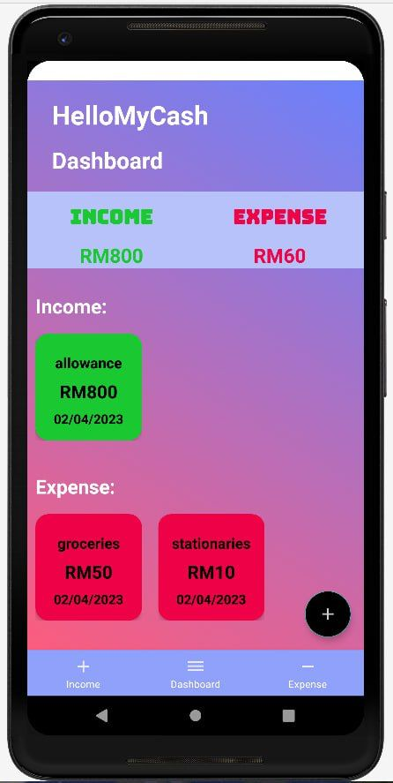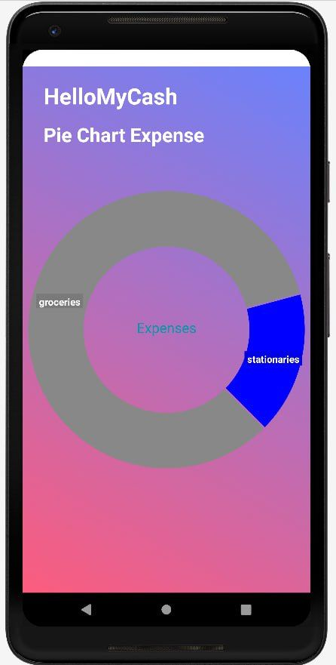

**Video**

**For further demonstration of the system:**

[**https://youtu.be/1nxSSsvD9RA**](https://youtu.be/1nxSSsvD9RA)

**Code in GitHub**

**The view of the coding**:

<https://github.com/yinuena/OOP-grp-project->

**Background of the project**

Our group choose to make user-friendly of financial android application that will gives benefit to the user from spending a huge amount of their money, therefore with this financial application that we create, the user will get the balance their money and to be more saving of their financial.

These user-friendly systems consist with a well-designed UI, fast loading time and strong data protection where users must create a strong password to log in and it will be set for the first time of using this app. By using our app, users can custom their expenses for categories like food, entertainment, rents, and numerous more categories that anyone can think of when budgeting their expenses. There will also be sections where users can check their expenses for according to the date. With this, the user is able to keep track and more organize. Other than that, but the automatically calculations will also make it easier for users to track their expenses.

The group have successfully created the financial android application with Java language that include the database as well for the storage purposes. In the coding, it contains main, user, name, date, budget, expense and database.

We have decided to create database (mySQL) because for the the reason to fit in large volume of data that have obtained. With this, the application will run slowly and avoid any error regarding the insufficient size of storage.

**Explanation of the Java Coding**

**Main.java**

* Acts as the admin of the program, where all of the function event happens.
  + - User and Name
    - Expense
    - Budget
    - Date
    - Database
* It connects with the database (MySQL), through the link and contain the username, database name and the password of the admin.
* It displays welcome message to the user upon entering the application.
* The user made choice of the menu.
  + - * which is the user’s detail (includes username, email, password, age, first name, middle name, and last name)
      * The date where the user will enter the day of the week, what date would the user key in the expense and budget.
      * Enter the currency once key in the expense.
      * Set the budget.
      * Key in the expense.
* Able to check if the budget exceeding the expense.

**User.java**

* Contain private class for username, email, password, and age.
* Contain getter and setter (save data and update data).
* Created for the user to enter their personal’s details (username, email, password, age, and name).
* Display the user’s detail (username, email, password, and age).

**Name.java**

* Are linked with the user.java.
* This java is used to gather the user’s name (first name, middle name, and last name).
* Use methods of getter and setter to retrieve the user’s name.

**Date.java**

* Contains attributes for the day, week, month, and year.
* Only uses the getter as the method.
* Act as the calendar function.
* The user will have to key in the date of the expense.
* The user will have to key in the expense for the day of the week (Sunday, Monday, Tuesday, Wednesday, Thursday, Friday, and Saturday).

**Expense.java**

* Contain attributes class for the date, amount, currency, and notes.
* Uses methods such as constructor, and getter and setter for the date, amount, currency and notes.
* Allow the user to enter the amount of the expense.
* Allow the user to put notes of the expense (explanation of the user’s expense).
* Allow the user to enter the type of currency of the expense (RM, Dollar, etc).
* Allow the user to add another expense to another date (option of yes or no **(y/n)**).
* The expense has connection with the date.
* The user will have to key in the expense for the day of the week (Sunday, Monday, Tuesday, Wednesday, Thursday, Friday, and Saturday).
* Display the total weekly expense week.
* Enter the week the user wants to key in the expense to at.
* Enter the date of the expense according to the format, year-month-day.

**Budget.java**

* Contain attributes of expense, budget, and currency.
* Contain methods of getter and setter for the budget, budget amount, and currency.
* Linked with the date.java
  + - The reason for this is because the budget will need the date of the week.
    - The user will need to key in the budget for the current week.
* Notify the user if the budget is exceeding the amount of the expense for the week.
  + - Will have the message of congratulate if the user have successfully spend within the budget.

Budget.java have two java which are the BudgetDay.java and BudgetWeek.java

**BudgetDay.java**

* + Contain the private class of the date (day) only.
  + This set the budget according to the day.

**BudgetWeek.java**

* Contain private class of the date (week) only
* This set the budget according to the week.

**Database.java**

* Contain attributes for url, port, db, username, passwd, and con
* Connect with database (mysql)
* Linked through URL of the database (with the use of static as this is the class with level variable) and with the admin’s username, passwd (password) and db (database name).
* Void function for connection (url, username, passwd, and db).
* Allow the user’s data (username, email, password, age, first name, middle name, and last name) into the database with void function insertRegistration.
* Allow the expense of the user into the database with void funcion insertExpense.
  + - Includes the date of the expense.